eCommerce Checkout Payment Gateway
Readme.txt for Magento 2.x Module

Ημερομηνία: 08/12/2022

=== Cardlink Check out Payment Gateway===
Contributors: cardlink
Tags: payments, payment-gateway
Requires at least: 2.2.6
Tested up to: 2.4.5
Requires PHP: 7.x
License: GPLv2 or later
License URI: http://www.gnu.org/licenses/gpl-2.0.html
Cardlink Payment Gateway allows you to accept payment through various schemes such as Visa, Mastercard, Maestro, American Express, Diners, Discover cards on your website.

== Description ==
Cardlink Payment Gateway allows you to accept payment through various schemes such as Visa, Mastercard, Maestro, American Express, Diners, Discover cards on your website, with or without variable installments.
This module aims to offer new payment solutions to Cardlink merchants for their Magento 1.x online store without having web development knowledge. However, for the initial module installation some technical knowledge will be required.

Merchants with e-shops (redirect cases only) will be able to integrate the Cardlink Payment Gateway to their checkout page using the CSS layout that they want. Also, they could choose between redirect or IFRAME option for the payment environment. Once the payment is made, the customer returns to the online store and the order is updated.
Once you have completed the requested tests and any changes to your website, you can activate your account and start accepting payments.

== Features ==
- A dropdown option for instance between Worldline, Nexi και Cardlink.
- Option to enable test environment (sandbox). All transactions will be re-directed to the endpoint that represents the production environment by default. The endpoint will be different depending on which acquirer has been chosen from instance dropdown option.
- Ability to define the maximum number of installments regardless of the total order amount.
- Ability to define the ranges of the total order amounts and the maximum number of installments for each range.
- Option for pre-authorization or sale transactions.
- Option for a user tokenization service. The card token will be stored at the merchant’s e-shop database and will be used by customers to auto-complete future payments.

- In-store checkout option: the merchant can configure the payment process to take place inside a pop up with IFRAME to mask the redirection process from the customers.
- A text field for providing the absolute or relative (to Cardlink Payment Gateway location on server) URL of custom CSS stylesheet, to apply custom CSS styles in the payment page.
- Translation ready for Greek & English languages.

== Installation ==
You need to manually upload the contents of the .zip file of the module’s latest version to your server’s web root folder that your Magento store is installed. You will first need to extract the file’s contents to a temporary folder. Then, go to the Cardlink\Checkout\Controller\Payment folder. Replace the Response.php file with the file that corresponds to your installed Magento version, Response-v2.2.php for any 2.2.x version and Response-v2.3.php for any version 2.3.x-2.4.x.

Depending on your hosting provider, you will probably have to be familiar with the process of transferring files using an FTP or SFTP client. If no FTP/SFTP access is provided, use your hosting provider’s administration panel to upload the folders to the folder of your Magento installation.

Using an SSH console, go to your web root folder (or the folder your Magento store is installed) and execute the following commands to enable the extension and execute its installation scripts.

# bin/magento module:enable Cardlink_Checkout
# bin/magento setup:upgrade
# bin/magento setup:di:compile

For hosting solutions running the Apache web server software, you will need to add the following lines to your web site’s root .htaccess file. These will manipulate all cookies set by your Magento store to allow customer sessions to persist after returning from the payment gateway. If you fail to properly set these, customers returning from the payment gateway will be automatically logged out from their accounts.

<IfModule mod_headers.c>
Header always edit Set-Cookie ^(.*)$ $1;SameSite=None;Secure
</IfModule>

If your hosting provider uses the Nginx web server instead, you will need to add/edit the following lines of code to your virtual host’s configuration file.

location / {
proxy_cookie_path / "/; SameSite=None; Secure";
…
}

If you are unsure or unfamiliar with the actions described above, please ask a trained IT person or contact your hosting provider to do them for you.

== Screenshots ==
- The Cardlink Payment Gateway settings screen used to configure the main Cardlink gateway (Stores > Configuration > Sales > Payment Methods).

- This is the front-end of Cardlink Payment Gateway plugin located in checkout page

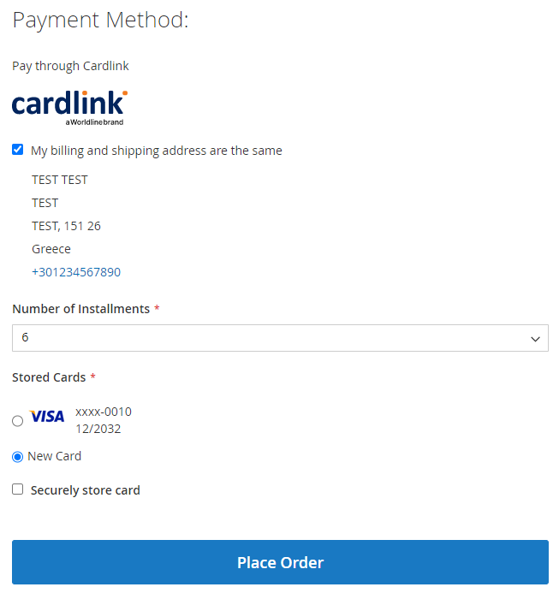

== Changelog ==
= 1.0.0 =
* Initial release

== Support tickets ==
In case that you face any technical issue during the installation process, you can contact the Cardlink e-commerce team at ecommerce_support@cardlink.gr .

